**CQI TASK FOR SOFTWARE CONSTRUCTION**

**GROUP MEMBERS:**

|  |  |
| --- | --- |
| Name | Enrollment No. |
| Ali Agha | (02-131222-107) |
| Muhammad Faizan | (02-131222-103) |
| Syed Muhammad Ammar Jilani | (02-131222-113) |

Develop project definition, vision statement, FR & NFR, 4 Uml diagrams, 2 low fidelity, and 2 high fidelity prototypes of the ADVANCED HOME SYSTEM. on the slides. A GitHub repository is to be made containing all the individual solutions to these tasks and a formal report containing all the tasks solutions. This can be done in a group of maximum 4 students.

**SOLUTION**

**Advanced Home System Project Definition:**

This project aims to develop a

**Smart Home Automation System**, a mobile and web application that gives users a single, centralized interface to control various smart devices. The primary issue this system solves is the user's struggle with managing fragmented smart devices, which often lack a unified, easy-to-use system. By providing a single point of control, the proposed solution will streamline the management of smart home devices. The project is a targeted task with a defined start and end, designed to solve specific business problems through successful software engineering.

**Vision Statement:**

**For** homeowners struggling with fragmented smart device control, **who** need a centralized way to manage their devices, **the** Smart Home Automation System **is a** mobile application **that** integrates and controls various smart devices from a single, user-friendly interface. **Unlike** the current, disparate control methods, **our product** provides seamless experience, unifying device management and enhancing overall home automation.

**Functional and Non-Functional Requirements**

**Functional Requirements (FR)**

These requirements describe what the system must **do**.

* Users should be able to turn smart lights on and off and adjust thermostat settings.
* The system must allow users to manage multiple smart devices from a single application.
* The application should process and trigger commands to designated devices (e.g., turning on a light, adjusting a thermostat).
* The system needs to retrieve and display the status of all connected devices (e.g., light on/off, current temperature).

**Non-Functional Requirements (NFR)**

These requirements detail the

**quality attributes** of the system, such as performance and security.

* **Reliability**: The system must consistently execute commands without failure.
* **Response Time**: The system should turn a smart light on or off and adjust thermostat settings within one second.
* **Security**: The system must ensure that only authorized users can control their smart devices. Device IDs and user information should be handled to prevent unauthorized access.
* **Usability**: The user interface must be intuitive and easy to navigate for all users, regardless of technical skill.

**Context Diagram**:

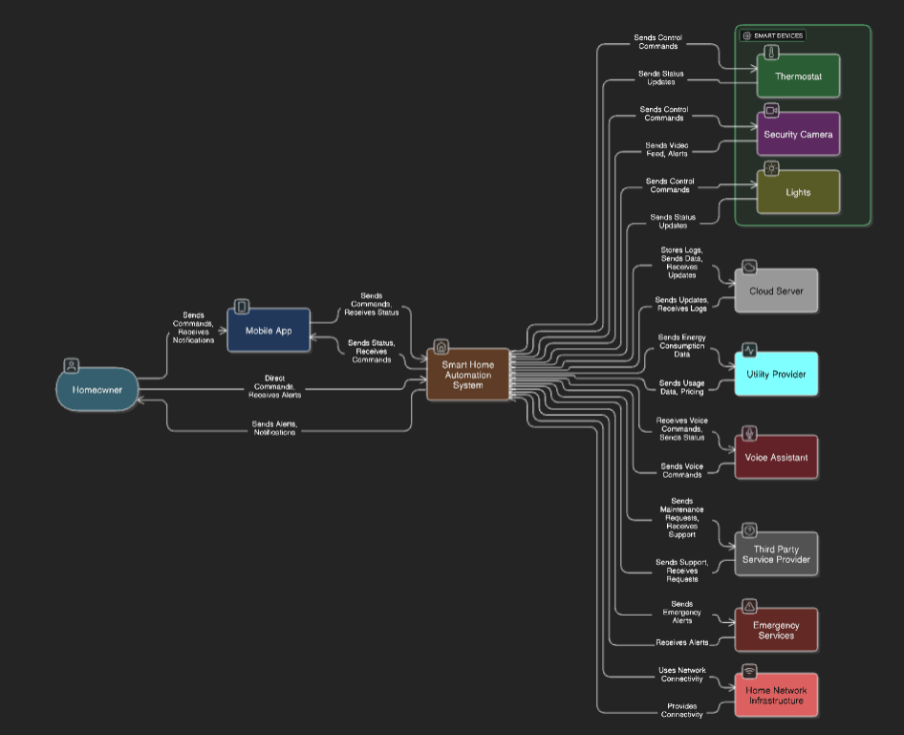

**Class Diagram:**

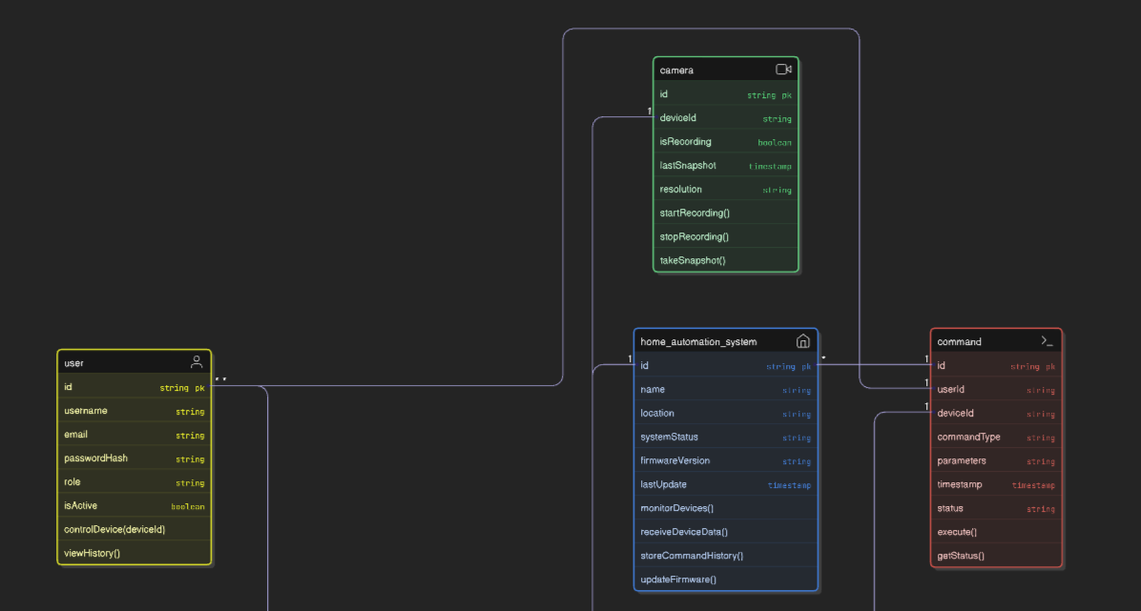

**Use Case Diagram:**

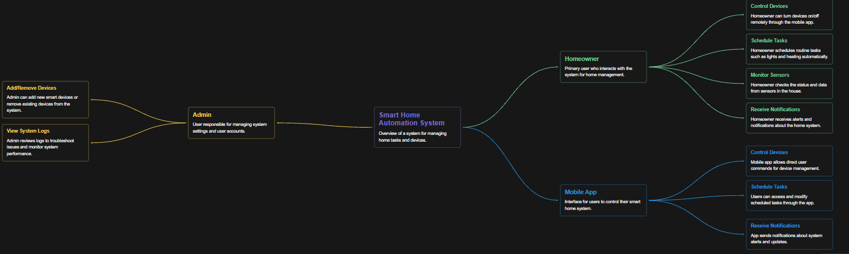

**Sequence diagram:**

**Prototyping: Bringing Ideas to Life**

Prototyping is a crucial stage in software development, acting as an iterative method to visualize the product. Early-stage prototypes help gather feedback from users, allowing developers to refine the interface and functionality before launching into full-scale development. In the context of our Smart Home Automation System, prototypes can be either low-fidelity or high-fidelity.

**Low-Fidelity Prototypes**

Low-fidelity prototypes are simple representations of the user interface that focus on layout and functionality, not aesthetics. They are quick to create and ideal for gathering early feedback.

1. **Dashboard Sketch:** A simple sketch on paper or a digital wireframe showing the main home screen with placeholders for a menu, a list of rooms, and a section for a quick overview of devices.
2. **Device Control Sketch:** A basic wireframe for a specific device, like a smart light. It would show a toggle button for on/off and a slider for brightness, demonstrating the core interaction without any visual design.

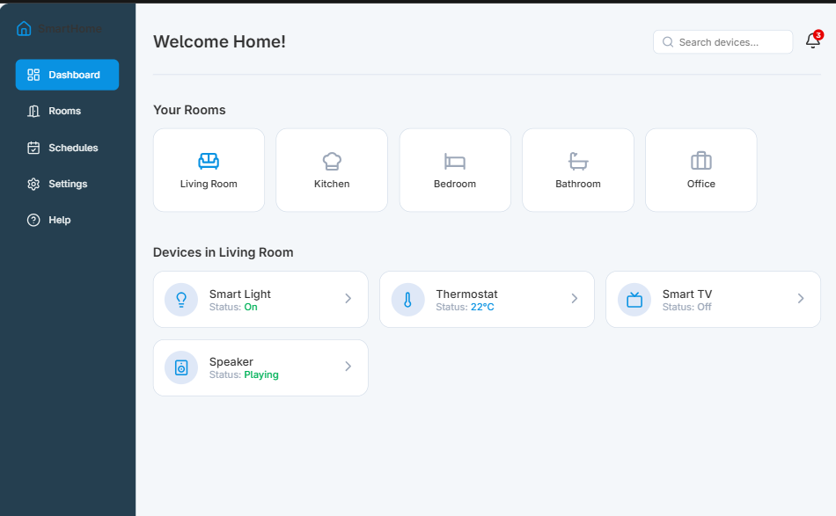

**High-Fidelity Prototypes**

High-fidelity prototypes are more detailed and interactive, closely resembling the final product. They are used to test the user experience with realistic visuals and interactions.

1. **Interactive Home Screen:** A detailed and interactive mock-up created in a tool like Figma or Visily. It would have a full color scheme, icons, and text, and allow a user to click on a room to navigate to the device list for that room.
2. **Interactive Device Control Screen:** A fully designed mock-up of a device control screen. For a smart light, it would include a visually appealing toggle switch and an interactive slider that provides real-time visual feedback, such as the light icon changing color or brightness. This prototype would be a close representation of the final app screen.

